Republic of North Macedonia

Ministry of Transport and Communications
Local Roads Connectivity Project - P170267
Project Implementation Unit
Ref. No.: LRCP-9034-MK-RFQ-A.3.2.5

REQUEST FOR QUOTATION

Project Title: Local Roads Connectivity Project - IBRD Loan No. 9034-MK
Source of Funding: International Bank for Reconstruction and Development

Contract Ref. No.: LRCP-9034-MK-RFQ-A.3.2.5

Contract Title: Website development, hosting and maintenance for LRCP and WBTTFP within MoTC
Purchaser: Ministry of Transport and Communications - PIU
Date: February 04, 2021

Dear Supplier,

1. You are invited to submit your price quotation(s) for the supply of the following items:
- Website development and hosting for LRCP and WBTTFP within MoTC
- maintenance for Website for LRCP and WBTTFP within MoTC

Information on technical specifications and required functionalities are attached.

2. The Republic of North Macedonia has received a Loan from the International Bank for Reconstruction and Development (IBRD) for financing from the World Bank toward the cost of the Local Roads Connectivity Project and Western Balkans Trade and Transport Facilitation Project. Projects will be implemented by Ministry of Transport and Communications (MoTC) through Project Implementation Unit (PIU). PIU has managing two Loans for following Projects: Western Balkans Trade and Transport Facilitation Project, IBRD Loan No.8929-MK (The Project implementation period is from June 06, 2019 to December 15, 2025) and Local Roads Connectivity Project, IBRD Loan No. 9034-MK. (The Project implementation period is from December 23, 2019 to December 31, 2024). Part of proceeds of the Loan for LRCP will be applied to eligible payments under this contract for procurement, development, hosting, establishing and maintenance of the website for LRC and WBTTF Projects within MoTC.
Procurement will be conducted through Request for Quotations (RFQ) method as specified in the World Bank’s “Procurement Regulations for IPF Borrowers” dated July 2016, revised November 2017 and August 2018 (“Procurement Regulations”).
In accordance to the “WB Guidance for procurement packages during the Corona Virus situation” the procedure for submission of quotations is strictly as stated in Paragraph 4 below.

3. Your quotation shall consist of:
- Invitation to Quote
- Terms and Condition of Supply - filled in and signed
- Technical Specification - filled in and signed
- Form of Quotation - filled in and signed
- Copy of Company Registration
- Adequate technical documentation and other pertinent information for each item quoted

4. For submission of Quotation, the Supplier will send an email to a specified email addresses in the Paragraph 9 of this RFQ with password protected document (Quotation) as an attachment. The Supplier shall use readable PDF format and submit one PDF document which will comprise all required documents from Paragraph 4 above (with Content on the beginning of the document).
Maximum size of the submitted PDF document shall be below 15 MB. In case that the document exceeds size of 15 MB, only the “Adequate technical documentation and other pertinent information for each item quoted” may be submitted in additional (separate) e-mail to a specified e-mail addresses. The additional PDF document shall bear same password as Quotation PDF document. Only PDF files are acceptable, zipped files (.zip; .rar; etc.) are not acceptable.
Within one hour after the Quotation submission deadline bidders must send the password of their password protected Quotation to the email addresses specified in the bidding documents.
Clients/Purchaser will confirm receipt of each Quotation as well as receipt of the password.
Original documents may be requested as part of the evaluation process and will be verified by the client/purchaser before the signing of the contract.

5. Your quotation in English language, should be accompanied by adequate technical documentation and catalogue(s) and other printed material or pertinent information (in English or Macedonian language) for each item quoted. Suppliers must submit copy of the company registration.

6. The deadline for receipt of your quotation by the Purchaser at the e-mail addresses indicated in Paragraph 9 is: February 18, 2021, 12:00 PM local time.

7. Your quotation(s) should be submitted as per the following instructions and in accordance with the attached Contract. The attached Terms and Conditions of Supply is an integral part of the Contract.

(i) PRICES: The price should be quoted in Macedonian Denars (MKD) for the Total Cost offered at final destination MoTC - PIU Office, without VAT and with including all other taxes and duties and any other fee, if applicable. Price quoted shall correspond to 100 % of the items specified and 100% of the quantities specified. Payment to suppliers will be made in MKD.

Note: In accordance with Clause 6 of the Law on Borrowing of the Republic of North Macedonia for a Loan from International Bank for Reconstruction and Development - World Bank by Loan Agreement for financing of the Local Roads Connectivity Project, Official Gazette of RNM No.261/19, VAT is exempted and shall not be stated in the Quotations, and in the Contract.

The end user’s address - place of final destination for delivery is:
Ministry of Transport and Communications (MoTC)
Local Roads Connectivity Project (LRCP)
Project Implementation Unit (PIU)
Address: Street “Dame Gruev”, Nо. 6, 1000 Skopje, Republic of North Macedonia

(ii) EVALUATION OF QUOTATION: Offers/quotations must be substantially responsive to the technical specifications and requested functionalities. Deviations of the quotation is not permitted/allowed. In case of deviations the quotation will be rejected. In the evaluation process of the evaluating of the quotation, the Purchaser will determine the evaluated price by making any correction for any arithmetical errors as follows:
(a) where there is a discrepancy between amounts in figures and in words, the amount in words will govern;
(b) where is a discrepancy between the unit rate and the line item total resulting from multiplying the unit rate by the quantity, the unit rate as quoted will govern;
(c) if a Supplier refuses to accept the correction, his quotation will be rejected.
The evaluated price shall not include Value Added Tax (VAT) in Republic of North Macedonia.

(iii) AWARD OF PURCHASE ORDER: The Purchaser shall award the contract to the Bidder offering the Most Advantageous Bid, in accordance with the applicable selection method. The Most Advantageous Bid is the Bid of the Bidder that meets the qualification criteria and whose Bid has been determined to be:
a. substantially responsive to the request for bids document; and
b. the lowest evaluated cost.

The Supplier will sign a Contract as per attached form of contract and terms and conditions of supply.

- Standstill Period
The Contract shall not be awarded earlier than the expiry of the Standstill Period. The Standstill Period shall be ten (10) Business Days. The Standstill Period commences the day after the date the Purchaser has transmitted to each Bidder the Notification of Intention to Award the Contract.

- Notification of the Intention to Award
The Purchaser shall send to each Bidder the Notification of Intention to Award the Contract to the successful Bidder. On receipt of the Purchaser’s Notification of Intention to Award, an unsuccessful Bidder has three (3) Business Days to make a written request to the Purchaser for a debriefing. The Purchaser shall provide a debriefing to all unsuccessful Bidders whose request is received within this deadline. Debriefings of unsuccessful Bidders may be done in writing or verbally. The Bidders shall bear their own costs of attending such a debriefing meeting. The communication will be only through e-mail at the e-mail addresses indicated in Paragraph 9.

- Notification of Award
Prior to the expiration of the Bid Validity Period and upon expiry of the Standstill Period and upon satisfactorily addressing any complaint that has been filed within the Standstill Period, the Purchaser shall notify the successful Bidder, in writing, that its Bid has been accepted. The communication will be only through e-mail at the e-mail addresses indicated in Paragraph 9.

(iv) VALIDITY OF THE OFFER: Your quotation(s) should be valid for a period of sixty (60) days from the deadline for receipt of quotation indicated in Paragraph 6.

8. Inspections and Audits

8.1 The Supplier shall carry out all instructions of the Purchaser which comply with the applicable laws where the destination is located.
8.2 The Supplier shall permit, and shall cause its Subcontractors and consultants to permit, the Bank and/or persons appointed by the Bank to inspect the Supplier’s offices and all accounts and records relating to the performance of the Contract and the submission of the bid, and to have such accounts and records audited by auditors appointed by the Bank if requested by the Bank. The Supplier’s and its Subcontractors and consultants’ attention is drawn to Clause 5 Fraud and Corruption of the Form of Contract, which provides, inter alia, that acts intended to materially impede the exercise of the Bank’s inspection and audit rights constitute a prohibited practice subject to contract termination (as well as to a determination of ineligibility pursuant to the Bank’s prevailing sanctions procedures).

9. Further information can be obtained from:
Ministry of Transport and Communications
Local Roads Connectivity Project
Attention: Mr. Slavko Micevski and/or Ms. Vlasta Ruzinovska
Address: Street “Dame Gruev”, No. 6, 1000 Skopje, Republic of North Macedonia
e-mail: harita.pandovska@mtc.gov.mk;
slavko.micevski.piu@mtc.gov.mk; vlasta.ruzinovska.piu@mtc.gov.mk;

10. Please confirm by e-mail the receipt of this invitation and whether or not you will submit the price quotation.
Sincerely,

Slavko Micevski, Procurement Specialist

FORM OF QUOTATION

_________(Date)

To: Ministry of Transport and Communications
Local Roads Connectivity Project
Street “Dame Gruev”, No. 6, 1000 Skopje, Republic of North Macedonia

We offer to execute the “Website development, hosting and maintenance for LRCP and WBTTFP within MoTC”, Contract No. LRCP-9034-MK-RFQ-A.3.2.5, in accordance with the Conditions of Contract accompanying this Quotation for the Contract Price of ________________________________ (amount in words and numbers) (____________) Macedonian Denars (MKD). We propose to complete the delivery of Website described in the Contract within a period of __________ days from the Date of Signing of the Contract.

This Quotation and your written acceptance will constitute a binding Contract between us. We understand that you are not bound to accept the lowest or any Quotation you receive.

We hereby confirm that this Quotation complies with the Validity of the Quotation required by the proposal documents.

Authorized Signature: ______________________________________

Name and Title of Signatory ______________________________________

Name of Supplier: _______________________________________

Address: _______________________________________

Phone Number ___________________

Fax Number, if any ___________________

e-mail address ___________________

FORM OF CONTRACT

Website development, hosting and maintenance for LRCP and WBTTFP within MoTC
LRCP-9034-MK-RFQ-A.3.2.5

THIS AGREEMENT number LRCP-9034-MK-RFQ-A.3.2.5, made on ________, __, 2021, between the Ministry of Transport and Communications of the Republic of North Macedonia (hereinafter called “the Purchaser”) on the one part and _____________________________________ (hereinafter called “the Supplier”) on the other part.

WHEREAS the Purchaser has invited quotation for “Website development, hosting and maintenance for LRCP and WBTTFP within MoTC” (description of goods) to be supplied by Supplier, viz. Contract, (hereinafter called “Contract”) and has accepted the Bid by the Supplier for the supply of goods under Contract at the sum of __________ (___________________________) hereinafter called “the Contract Price”.

NOW THIS AGREEMENT witnessethes as follows:
- The following documents shall be deemed to form and be read and construed as part of this agreement, viz:
- Invitation to Quote; Term and Conditions of Supply, Technical Specification;
- Addendum (if applicable);
- Taking into account payments to be made by the Purchaser to the Supplier as hereinafter mentioned, the Supplier hereby concludes an Agreement with the Purchaser to execute and complete the supply of Contract and remedy any defects therein in conformity with the provisions of Contract.
- The Purchaser hereby covenants to pay in consideration of the goods supply and acceptance of Contract and remedying of defects therein, the Contract Price in accordance with Payment Conditions prescribed by Contract.
- Termination
4.1 Termination for Default

The Purchaser, without prejudice to any other remedy for breach of Contract, by written notice of default sent to the Supplier, may terminate the Contract in whole or in part:

if the Supplier fails to deliver any or all of the Goods within the period specified in the Contract, or within any extension thereof granted.

if the Supplier fails to perform any other obligation under the Contract; or

if the Supplier, in the judgment of the Purchaser has engaged in fraud and corruption, as defined in Clause 5 below, in competing for or in executing the Contract.
(b) In the event the Purchaser terminates the Contract in whole or in part, the Purchaser may procure, upon such terms and in such manner as it deems appropriate, Goods or Related Services similar to those undelivered or not performed and the Supplier shall be liable to the Purchaser for any additional costs for such similar Goods or Related Services. However, the Supplier shall continue performance of the Contract to the extent not terminated.
4.2 Termination for Insolvency.

The Purchaser may at any time terminate the Contract by giving notice to the Supplier if the Supplier becomes bankrupt or otherwise insolvent. In such event, termination will be without compensation to the Supplier, provided that such termination will not prejudice or affect any right of action or remedy that has accrued or will accrue thereafter to the Purchaser.
4.3 Termination for Convenience.

The Purchaser, by notice sent to the Supplier, may terminate the Contract, in whole or in part, at any time for its convenience. The notice of termination shall specify that termination is for the Purchaser’s convenience, the extent to which performance of the Supplier under the Contract is terminated, and the date upon which such termination becomes effective.

The Goods that are complete and ready for shipment within twenty-eight (28) days after the Supplier’s receipt of notice of termination shall be accepted by the Purchaser at the Contract terms and prices. For the remaining Goods, the Purchaser may elect:

to have any portion completed and delivered at the Contract terms and prices; and/or
      - to cancel the remainder and pay to the Supplier an agreed amount for partially completed Goods and Related Services and for materials and parts previously procured by the Supplier
- Fraud and Corruption
If the Purchaser determines that the Supplier and/or any of its personnel, or its agents, or its Subcontractors, consultants, service providers, suppliers and/or their employees has engaged in corrupt, fraudulent, collusive, coercive or obstructive practices (as defined in the prevailing Bank’s sanctions procedures), in competing for or in executing the Contract, then the Purchaser may, after giving 14 days’ notice to the Supplier, terminate the Supplier's employment under the Contract and cancel the contract, and the provisions of Clause 4 shall apply as if such expulsion had been made under Sub-Clause 4.1.
- Inspections and Audits
6.1 The Supplier shall carry out all instructions of the Purchaser which comply with the applicable laws where the destination is located.

The Supplier shall permit, and shall cause its Subcontractors and consultants to permit, the Bank and/or persons appointed by the Bank to inspect the Supplier’s offices and all accounts and records relating to the performance of the Contract and the submission of the bid, and to have such accounts and records audited by auditors appointed by the Bank if requested by the Bank. The Supplier’s and its Subcontractors and consultants’ attention is drawn to Clause 5 Fraud and Corruption, which provides, inter alia, that acts intended to materially impede the exercise of the Bank’s inspection and audit rights constitute a prohibited practice subject to contract termination (as well as to a determination of ineligibility pursuant to the Bank’s prevailing sanctions procedures).

Signature and seal of the Purchaser:  FOR AND ON BEHALF OF THE  Ministry of Transport and Communications  _______________________  Name of Authorized Representative | Signature and seal of the Suppler:  FOR AND ON BEHALF OF  ___________________________  Name of Authorized Representative

Terms and Conditions of Supply

Project Title: Local Roads Connectivity Project - IBRD Loan No. 9034-MK
Purchaser: Ministry of Transport and Communications

Consignee: Ministry of Transport and Communications – Project Implementation

Unit (PIU)

Contract Ref. No.: LRCP-9034-MK-RFQ-A.3.2.5

Contract Title: Website development, hosting and maintenance for LRCP and WBTTFP within MoTC

- Prices and Schedules for Supply

Item No. | Description | Unit | Quantity | PRICE  (MKD)
1. | Website development, hosting and establishing – for both Projects – LRCP and WBTTFP | Lump sum | 1 (one)
2. | Maintenance and technical support for website - for both Projects – LRCP and WBTTFP (57 months duration) | Month | 57  (fifty seven)
TOTAL (MKD)
Note: In case of discrepancy between unit price and total derived from unit price, the unit price shall prevail.

Breakdown of cost for Website development, hosting and establishing – for both Projects (Item no. 1)
To be filled by Supplier, additional services may be added. Total price should be equal with Item no.1.
1 | 2 | 3 | 4 | 5 | 6
Service  N° | Description of Services | Unit  (Work hour) | Quantity | Unit price | Total Price  per Service  (Col. 4*5)
 | Website development and training
1 | Website domain registration
2 | Website hosting at server
3 | Primary content development
4 | Secondary content development
5 | Banner/Button development
6 | Administrator module development
7 | Content management system (CMS) module development
8 | Grievance Redress Mechanism (GRM) module
9 | Website administration
10 | Logo development and patenting
11 | Link to social network
12 | Languages
13 | Training
14 | Monitoring application (dashboard)
Total Price for Website (Item no. 1 stated above)

Maintenance Requirements: The supplier shall provide regular maintenance services and technical support for established website – for both Projects - LRCP and WBTTFP. Duration of maintenance services will be through whole period of Projects implementation, starting from March 2021 up to end of November 2025, in total 57 months. Payment for maintenance will be on monthly base according price per month stated in Item no. 2 above.

- Fixed Price: The prices indicated above are firm and fixed and not subject to any adjustment during contract performance.

- Delivery Schedule: The Website should be delivered, installed, configured and tested at the Ministry of Transport and Communications – WBTTF Project, within 60 days, following the date of the notification of award.

- Applicable Law: The Contract shall be interpreted in accordance with the laws of the Republic of North Macedonia.

- Resolution of Disputes: The Purchaser and the Supplier shall make every effort to resolve amicably by direct informal negotiation any disagreement or dispute between them under or in connection with the Contract. In the case of a dispute between the Purchaser and the Supplier, the dispute shall be settled in accordance with the laws of the Republic of North Macedonia.

- Payment for your invoice for Item no. 1 – Website will be made 100% against delivery and issuance of Acceptance Certificate by the Purchaser, in 30 days at latest through bank account according to the invoice payment instruction. Payment will be made in MKD.
Payment for your invoices for Item no. 2 – Maintenance will be made on monthly base according price per month stated in Item no. 2 above. Payment will be made in MKD.

- Warranty: Goods offered should be covered by Supplier’s warranty of 12 (twelve) months from the date of issuance of Acceptance Certificate by the Purchaser. The Warranty Period of Goods shall formally commence at the date of the issuance of the Acceptance Certificate. Please specify warranty period and terms in details.

- Defects: All defects will be corrected by the Supplier without any cost to the Purchaser within 2 (two) days from the date of notice by Purchaser.
Name and address of the Purchaser, at which the defects are to be corrected by the supplier onsite, within the warranty period:
Ministry of Transport and Communications
Western Balkans Trade and Transport Facilitation Project
Address: Street “Dame Gruev”, No. 6, 1000 Skopje, Republic of North Macedonia
Name and address of supplier service facility through which the defects are to be corrected within the warranty period (please fill in):
__________________________________________________________________________

- Force-Majeure: The supplier shall not be liable for penalties or termination for default if and to the extent that its delay in performance or other failure to perform its obligations under the Contract is the result of an event of Force-Majeure.

For purposes of this clause, “Force-Majeure” means an events beyond the control of the Supplier and not involving the Supplier’s fault or negligence and not foreseeable. Such events may include, but not restricted to, act of Purchaser in its sovereign capacity, wars or revolutions, fires, floods, epidemics, quarantine restrictions, and freight embargoes.

If a Force-Majeure situation arises, the Supplier shall promptly notify the purchaser in writing of such condition and the cause thereof. Unless otherwise directed by the Purchaser in writing, the Supplier shall continue to perform its obligations under the Contract as far as is reasonably practical, and shall seek all reasonable alternative means for performance not prevented by Force-Majeure event.

- Required Technical Specifications

(i) General Description
(ii) Specific details and technical standards
(iii) Performance Parameters
Supplier confirms compliance with above specifications.
In case of deviations supplier to list all such deviations.

- Failure to Perform: The Purchaser may cancel the Agreement if the Supplier fails to deliver the Goods, in accordance with the above terms and conditions, in spite of a 21-day notice given by the Purchaser, without incurring any liability to the Supplier.

NAME OF SUPPLIER __________________________________________
Address of the Supplier __________________________________________
Authorized Signature and Stamp ___________________________________
Place:
Date:

TECHNICAL SPECIFICATIONS (REQUIRED AND OFFERED)

Project Title: Local Roads Connectivity Project - IBRD Loan No. 9034-MK
Title of Procurement: Website development, hosting and maintenance for LRCP and WBTTFP
within MoTC
Ref.No.: LRCP-9034-MK-RFQ-A.3.2.5
Quantity: As per the technical specifications below

Required Specifications for Website (for both Projects):

- Introduction
The Republic of North Macedonia and the International Bank for Reconstruction and Development signed Loan Agreements for implementation of Western Balkans Trade and Transport Facilitation Project and Local Roads Connectivity Project.

Projects will be implemented by Ministry of Transport and Communications (MoTC) through Project Implementation Unit (PIU). PIU has managing two Loans for following Projects: Western Balkans Trade and Transport Facilitation Project, IBRD Loan No. 8929-MK (The Project implementation period is from June 06 2019 to December 15 2025) and Local Roads Connectivity Project, IBRD Loan No. 9034-MK. (The Project implementation period is from December 23 2020 to December 31 2024). Part of proceeds of the Loan for LRCP will be applied to eligible payments under this contract for procurement, development and establishment of the website for LRCP and WBTTFP Projects within MoTC.

- Domain and hosting
The hosting shall be limited to the territory of the Republic of North Macedonia and cannot be transferred under any circumstances.

The domain for the website will be specified by the Purchaser. The specified domain shall be registered by the Supplier for period of 5 years. The cost of domain registration must be covered by the Supplier.

The Website shall be hosted at the server located in the MoTC. The server configuration is as follows:
- Windows based with SQL 2014,
- IIS Version 7.0,
- NET Framework 3.5,
- 32.0 GB memory (RAM)

- Website development
In this section, the minimum requirements related to the website development are defined. The platform that will be used for website development must be specified in the Supplier`s offer.

  - Proposed structure
The proposed structure describes the initial point and it can be subject of change during the development phase.

The website shall be with modern design, easy for navigation and with logical connection between the contents. The design shall include banners on the main page for direct access to certain content specified by the Purchaser. The Supplier shall propose at least three templates of appropriate design. The final design and structure of the website will be defined with close cooperation between the Supplier and the Purchaser.

    - Primary content
The website shall include the following minimum primary contents but not limited to:
- Home page
- About us
- Projects
- News
- Contact

    - Secondary content
The secondary content represents the categories of information that will be grouped by the content. Categories shall be "branched" into subcategories up to the third level. The secondary content will be defined with close cooperation between the Supplier and the Purchaser.

    - Functionality
The website shall consist of the following modules:
- Administrator module
- Content management system (CMS) module,
- Grievance Redress Mechanism (GRM) module

All modules shall be accessible through all standard internet browsers. Multiple users shall be able to work at the same time in separate content pages.

The website shall be administrated by the Supplier. Access to the administrator module shall have only administrator with appropriate user name and password, nominated by the Supplier. The administrator shall be able, but not limited to:
- Add new administrator
- Add or remove content editor
- Add or remove module/page/category
- Edit categories and subcategories
- Edit the content through the content management system
- Review the logs

The content management system shall be managed by the Purchaser. Access to the content management system shall have only content editors with appropriate user name and password and only to the module / page / category to which it has a privilege granted by the Administrator. The content editors will be nominated by the Purchaser. The content editor shall be able to edit the content which is consist of:
- Title
- Brief description
- Main picture (optional)
- Content that is an HTML block that which created with the so-called
- WYSIWYG editor
- Category content

The prepared content by the content editor shall be reviewed in WYSIWYG editor and approved by the content supervisor nominated by the Supplier prior to publishing on the website. The supervisor shall be notified at the specified e-mail for any request of approval.

The content management system shall support the following types of contents:
- Addresses (URL)
- Links
- All types of documents
- All types of pictures
- Photo gallery
- All type of videos
- All types of audios
- Embedded codes.

For each publishing, editing or removing of content, a log shall be kept of who, when and what action was performed. Administrator shall be able to view these logs. On the Purchaser requests, the Supplier shall provide the logs.

The Grievance Redress Mechanism (GRM) System module will be used for grievance and environmental and social safeguards by the public. Access to the GRM module shall have the grievance supervisor (PIU Environmental and Social Specialist) with appropriate user name and password, nominated by the Purchaser. Also, access to the GRM module shall have the grievance contact persons with appropriate user name and password, nominated by the local self-government units. The public website user shall have option to express the grievance directly to the Purchaser or directly to the local self-government unit`s without registration. In case of direct contact to the self-government unit, the website public user shall have option to express general issue or issue related to certain local self-government`s project. This module shall be able to send notification to the e-mail address of the grievance supervisor and the appropriate grievance contact persons from the local self-government. Also in case of direct contact to the self-government unit, the GRM module shall be able to send notification to the e-mail address of the grievance supervisor PIU ES Specialist. The prepared answer by the grievance contact person shall be approved by the PIU ES Specialist - grievance supervisor prior to sending it to the e-mail address of the public website user. The supervisor - PIU ES Specialist shall be notified at the specified e-mail for any received answer. The Form for grievance will be defined according to Purchaser’s requirements. The GRM system shall also be accessed by banner on the main page.

    - Style and design
The design should be modern, interactive and user friendly. A unique logo of the Project Implementation Unit within the MoTC shall be designed and patented. The website shall look well on all devices (computers, tablets and smartphones). The website shall be 100% responsive and accessible through all standard internet browsers

    - Social networks
The website shall have opportunity for creating links and sharing the content with LinkedIn.

  - Additional requirements
    - Accessibility, availability and response time.
In order to enable access for people with disabilities, the website should meet the "AA" level of web accessibility according to the web accessibility guide WCAG 2.0 (http://wcag.mioa.gov.mk).

A minimum of 99% availability of the Website shall be guaranteed. Availability is measured on a monthly basis, as a quotient of the total number of hours when the Website is available with the total possible number of hours. Planned terminations must be announced three days in advance and approved by the Purchaser. These terminations should be scheduled in the period from 02:00 to 06:00 local time.

The average response time for all pages should be less than 4 seconds.

The Supplier shall measure the availability and response time and include them in reports. The measurement of the response time (average response time) should be done in a way that will reflect it during normal use of the website.

    - Security
The Website shall have an appropriate authorization and authentication mechanism implemented in order to prevent unauthorized access to the admin, content management module and public contact module.

    - Code validation
The entire code of the website shall be valid in accordance with the W3C (World Wide Web Consortium) specification.

    - Tools search optimization
The Website shall be accessible for search engine spiders and should be well optimized and coded for search engines.

    - Language
The Website shall be available in Macedonian and English language.

    - Source code
The Supplier is obliged 15 (fifteen) days before the expiration of the contract, to submit to the Purchaser the last backups of the data and the complete source code and database, together with an instruction explaining how to set up the website to work in a new environment, in electronic format on portable medium. The website delivered and installed would be property of the Purchaser – Ministry of Transport and Communications (MoTC).

    - Operation
Before putting of the website into operation, the contactor shall enable testing of the website in the test environment for a period of 5 days. The website will be put into operation after previously obtained approval from the Purchaser. The website shall be developed within 60 days upon signing of the Contract. The grievance module shall be prepared and operational within 30 days upon signing of the Contract.

    - Training
The Supplier shall provide training for 15 users of the website, before putting the website into operation. The training should be accompanied by appropriate written material in the form of instructions.

- Warranty period, maintenance services and technical support
The Supplier shall provide regular maintenance services and technical support for warranty period and for whole period of Projects implementation, starting from March 2021 up to end of November 2025, in total 57 months. Payment for maintenance will be on monthly base according price per month stated in the offer.

  - Backup
The Supplier shall provide at least daily back-up of the website. The details will be defined with close cooperation between the Supplier and the Purchaser.

Upon a request for backup data recovery submitted by the Purchaser, the Supplier shall act and execute the recovery as soon as possible, but not more than 12 hours.

  - Testing and scanning
On a monthly basis, the Supplier shall perform testing and scanning of the website as follows:
- Periodical testing for dead links in the website
- Periodical testing of the Website performances
- Periodical scanning of the Website vulnerability

The results of testing and scanning shall be presented in the monthly report.

  - Monitoring and reports
The Supplier shall continuously monitor the operation and behavior of the website and present the results in the monthly reports. The monthly report should contain the following elements, but not limited to:
- Availability
- Average response time during the day, average per hour
- Number of 404 answers (page does not exist) per day;
- Number of visits to the Website per day;
- Performance results;
- "Dead links" results;
- Security scan results;
- Logs
- Load test results;
- Backup data recovery test results
- Website traffic overview (Periodic Reports for popularity of pages, visits, visitors, review of answered questions, follow-up complaints and suggestions, etc.)

The Supplier shall provide a suitable monitoring and reporting application (Dashboard).

  - Failures and problems
The problems that would arise within the warranty period, will be solved and implemented by the Supplier without any cost. The Supplier shall respond to the reported failure or problem by the Purchaser no later than the next working day. Failures and problems will be reported using e-mail.

Below is presented basic idea of the Purchaser for look and content of the website, it is only for better explanation to Suppliers of Purchaser needs in regard to future website.



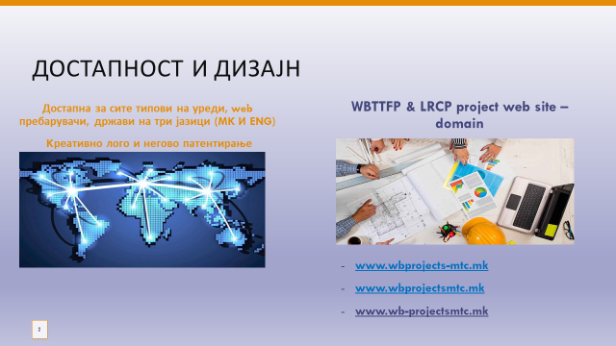

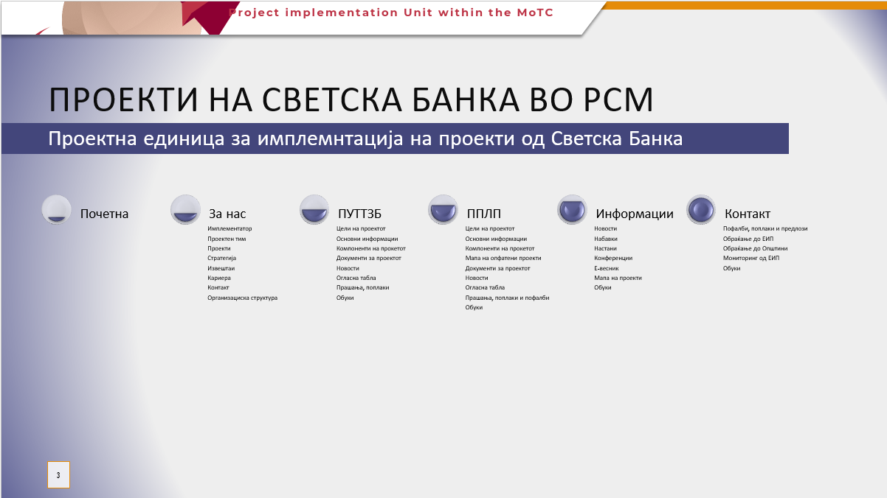

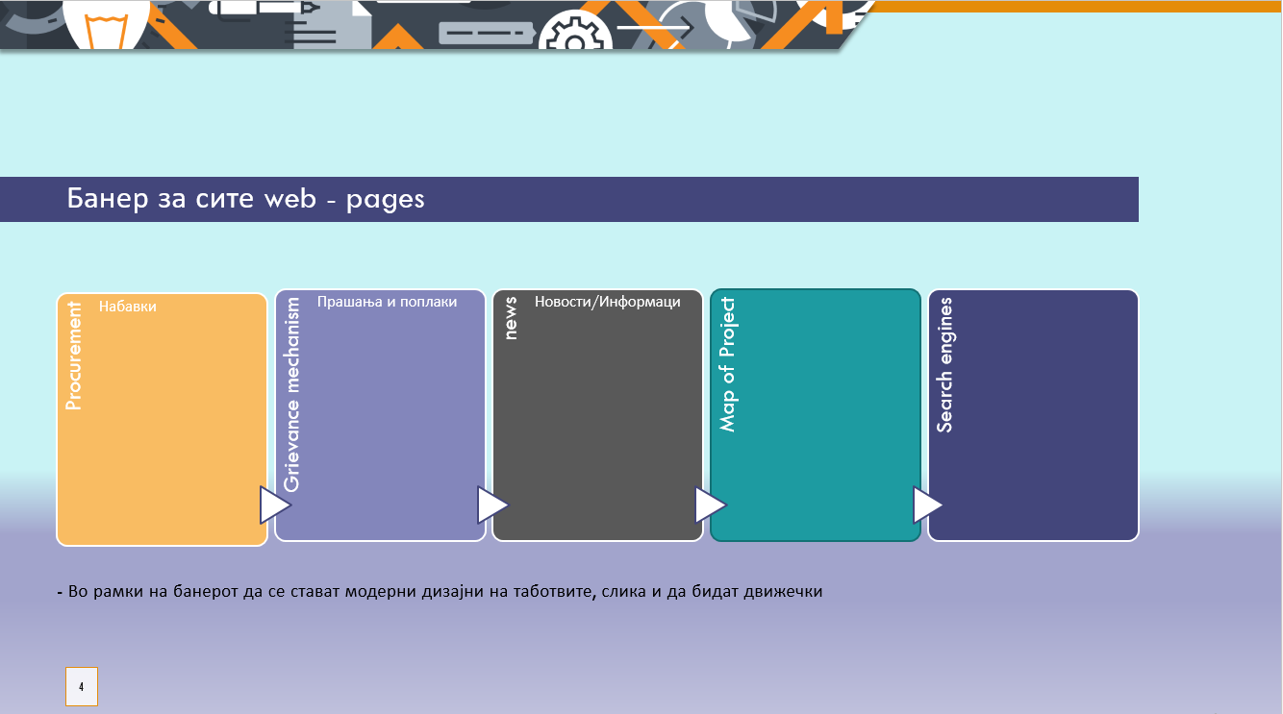

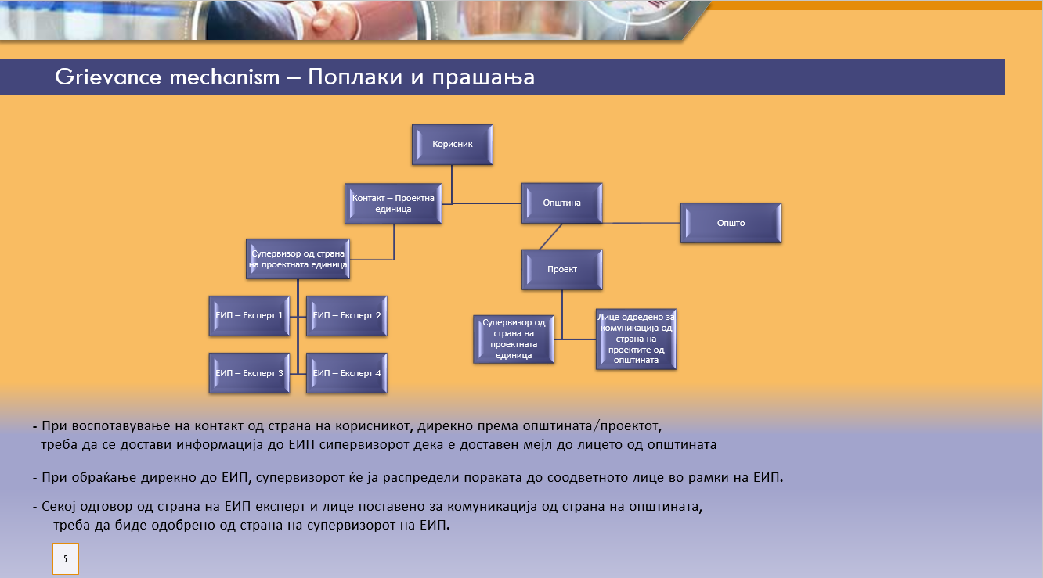

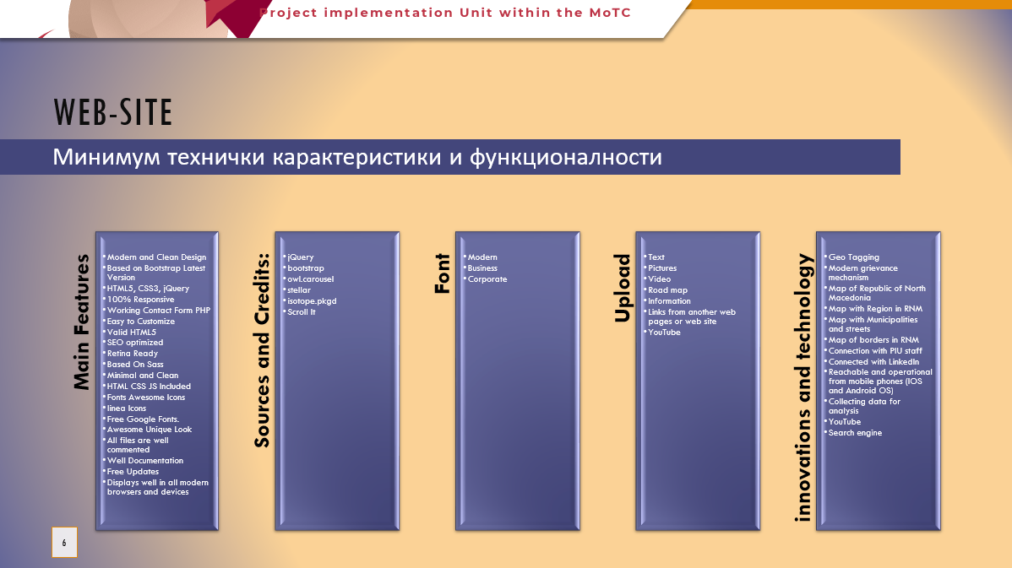

Offered Specifications for Website (for both Projects) - to be filled in by Supplier:

2. Domain and hosting
3. Website development
4. Warranty period, maintenance services and technical support

NAME OF SUPPLIER __________________________________________
Address of the Supplier __________________________________________
Authorized Signature and Stamp ___________________________________
Place:
Date:

